Accept a character from console and check the case of the character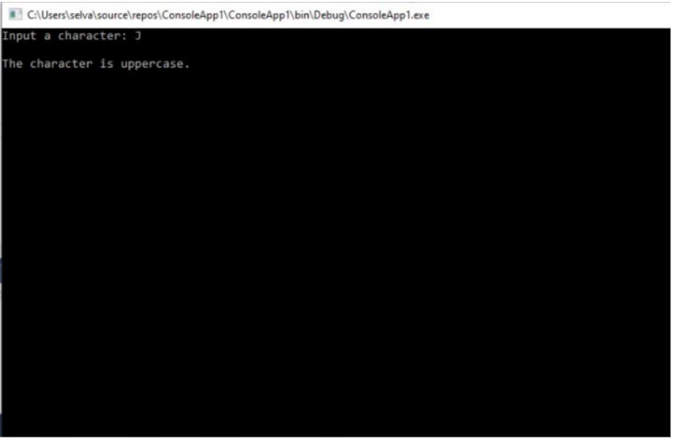

Write a program to accept any character from keyboard and display whether it is vowelor not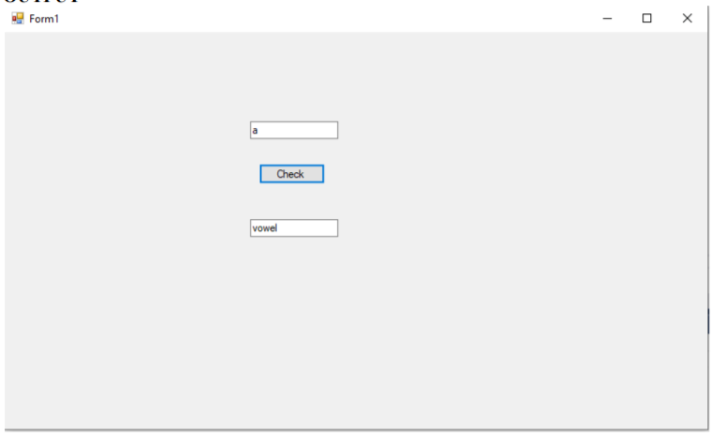

Write a VB.Net program to accept a string and convert the case of the characters.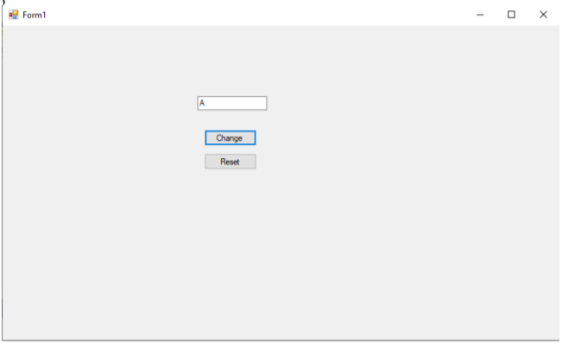

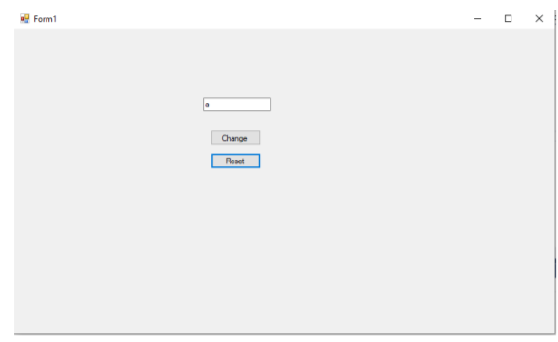

Develop a menu based VB.Net application to implement a text editor with cut, copy, paste, save and close operations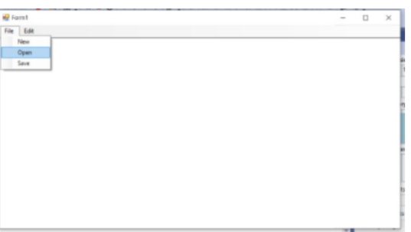

Write a program to implement a calculator with memory and recall operations.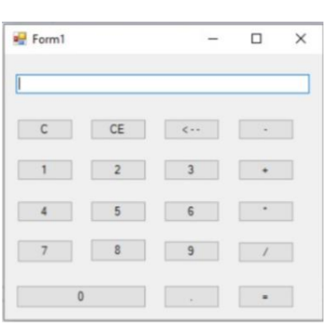

Develop a form in VB.NET to pick a date from Calendar control and display the day, month, and year details in separate text boxes.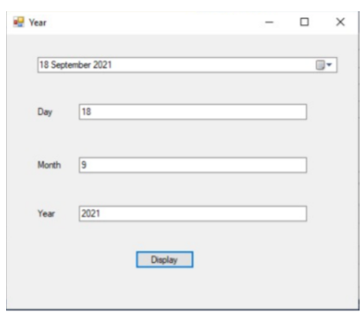

**EX 7:**

Develop a VB.Net application to perform timer based quiz of 10 questions

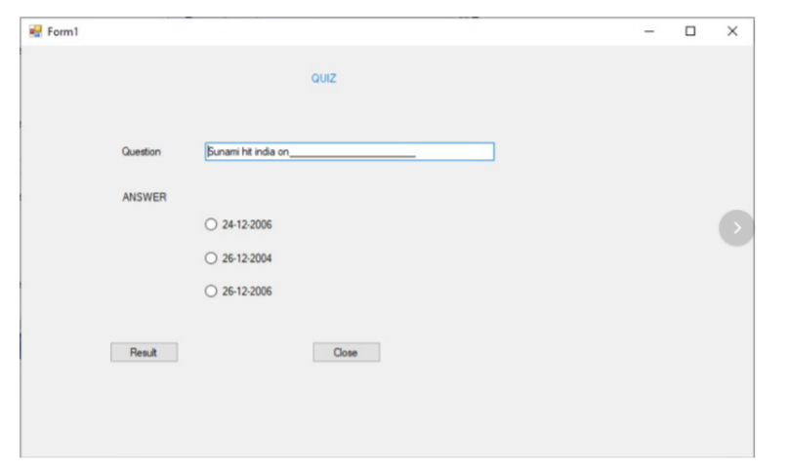

**EX 8:**

Develop a VB.Net application using the File and Directory controls to implement a common dialog box

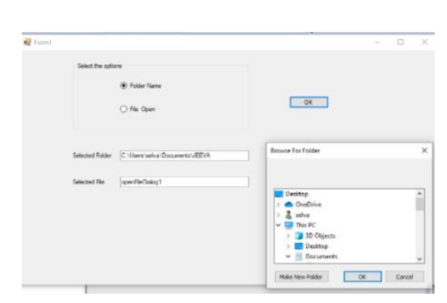

**EX 9:**

Develop a database application to store the details of students using ADO.NET

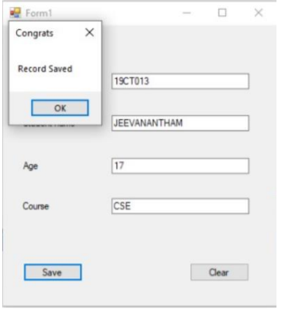

**EX 10:**

Develop a database application using ADO.NET to insert, modify, update and deleteoperations.

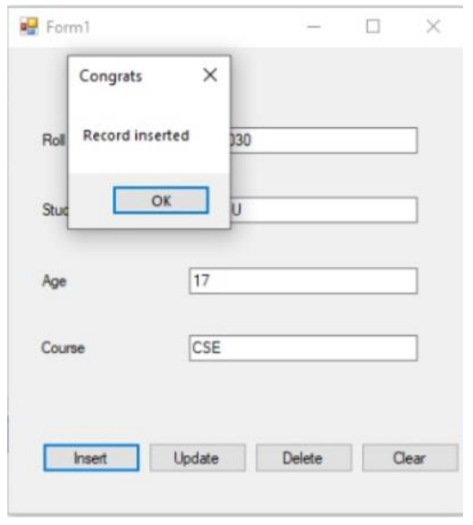

**EX 11:**

Develop a VB.Net application using Datagrid to display records.

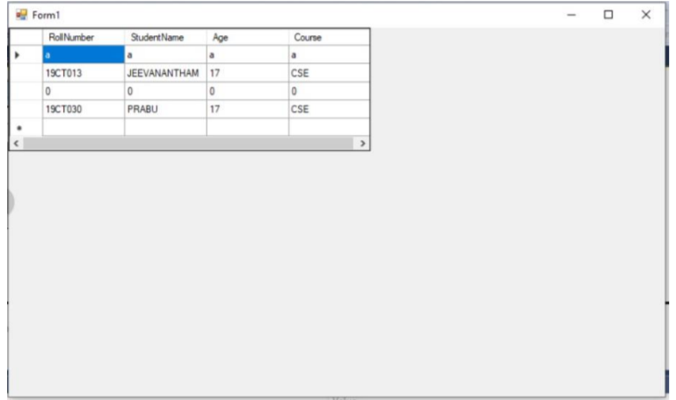

**EX 12:**

Develop a VB.Net application using Datagrid to add, edit and modify records

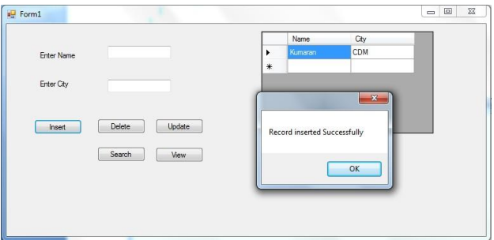

**EX 13:**

Create a simple ASP.NET page to Output Text with a form, two HTML text boxes, an HTML button, and an HTML element. Create an event procedure for thebutton.

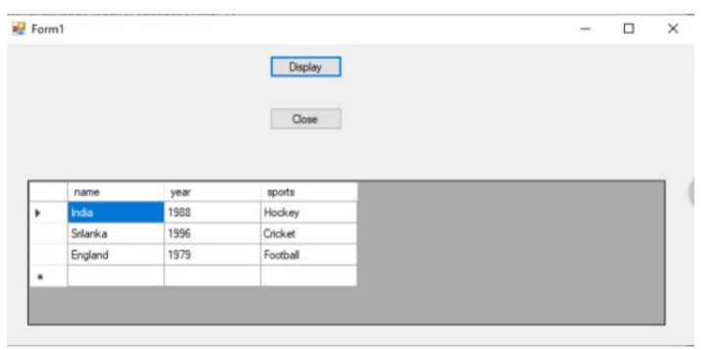

**EX 14:**

Create a web application in ASP.NET using three different controls to the ASP.NETpage for reserving rooms in hotel. The three controls are a button control, a label control, and a drop down list control.

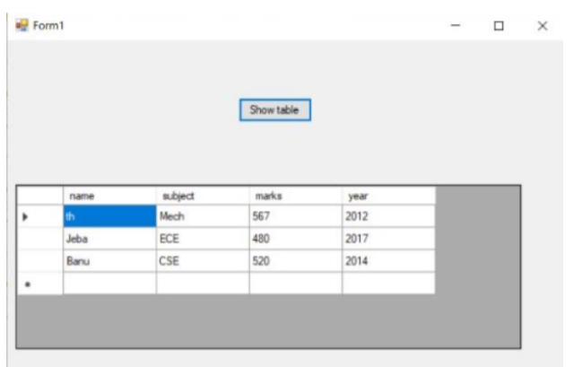

**EX 15:**

Create a application for Accessing a SQL Database by Using ADO.NET by connecting to the SQL Server database and call a stored procedure. You then displaythe data in a Repeater control.

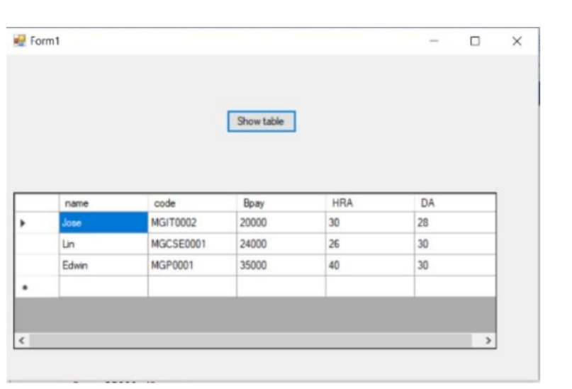

**EX 16:**

Develop a web application to read the details of the selected country stored in XML database and display back to the user using Webcontrol

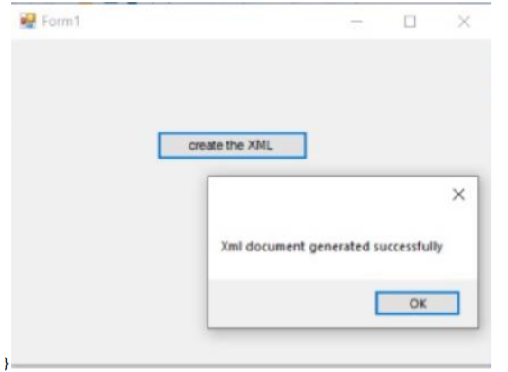

**EX 17:**

Develop a web application to read an XML document containing subject, mark scored, year of passing into a Dataset

